High-Level Architecture (What you’ve built)
🔷 Flow (end-to-end)
User → DNS → App Gateway → Container App → Azure OpenAI / Search → Response

🏗️ 1. Entry Layer – DNS + App Gateway
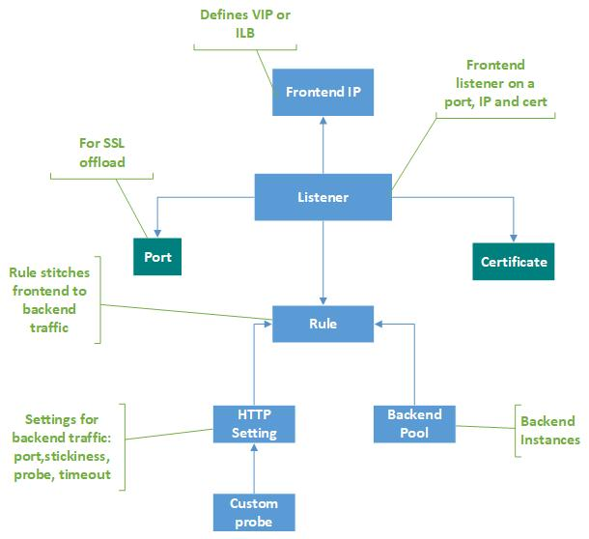
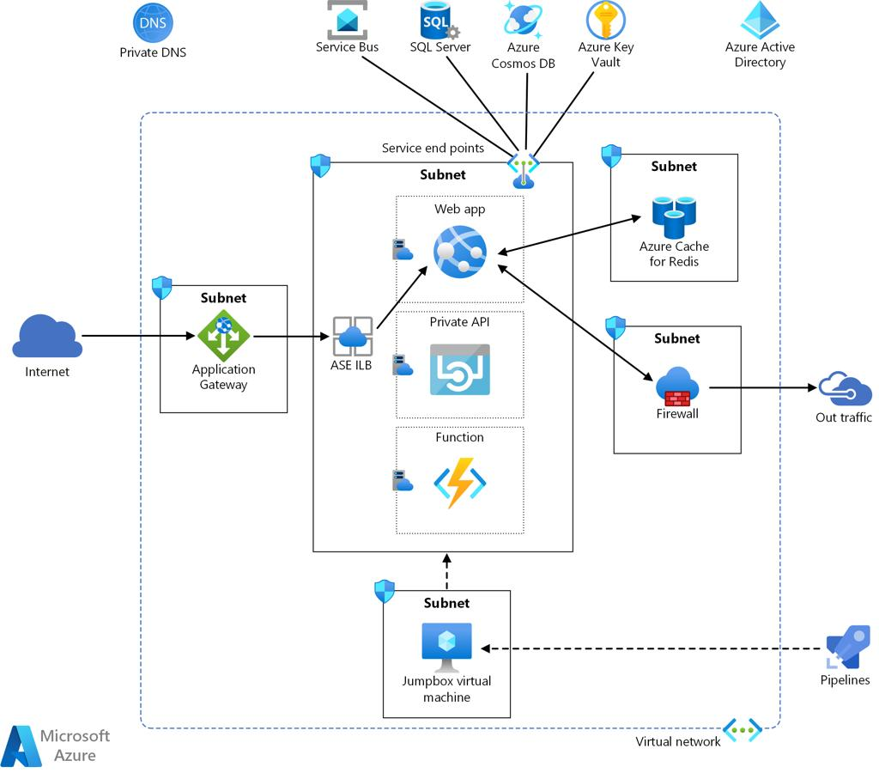
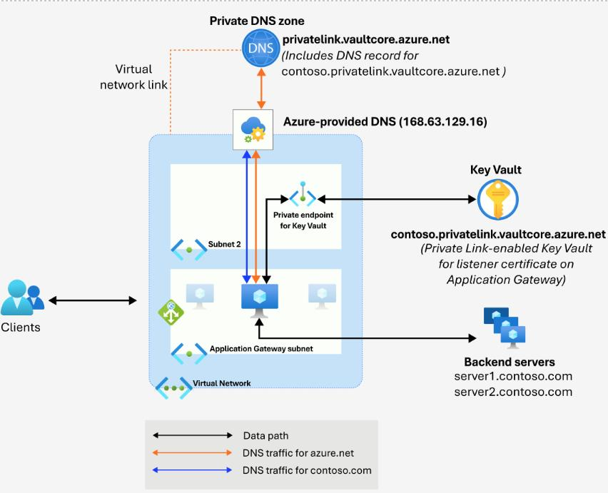
6
Components:
- DNS → stg-chatgpt.nonprod-krispay.com
- Azure Application Gateway
👉 What happens:
- User hits:
https://stg-chatgpt.nonprod-krispay.com
- DNS resolves → App Gateway public IP
- App Gateway:
  - Terminates SSL (using your cert)
  - Uses:
    - Listener
    - Rule
    - Backend Pool
- Routes traffic → Container App (private endpoint)

🧠 Why App Gateway?
- Centralized entry point
- WAF (if enabled)
- SSL offloading
- Routing control
👉 In your case: shared across DEV/UAT/STG

🧱 2. Network Layer (Critical Part)
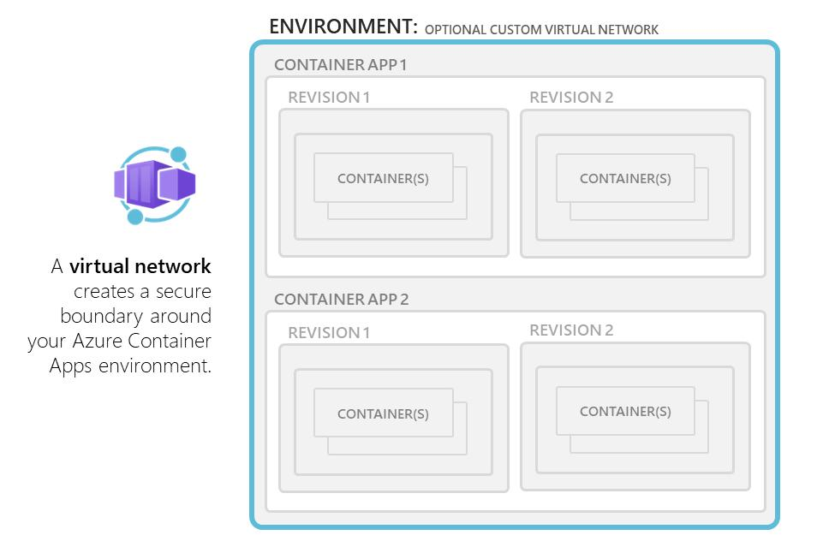
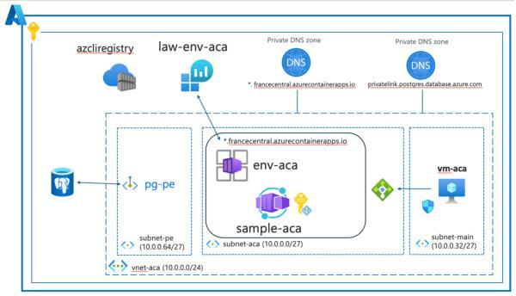
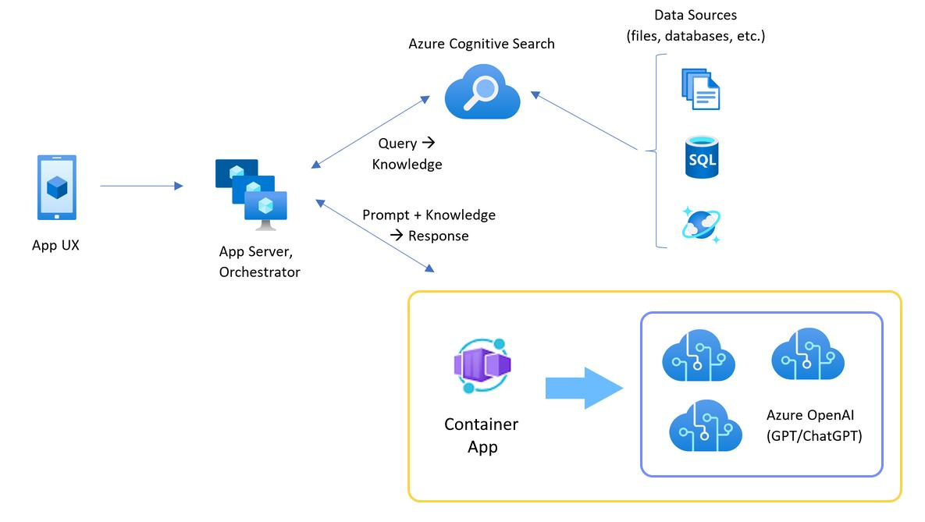
6
Key elements:
- VNet → DEVUAT-APP-VNET
- Dedicated Subnet (/27) → Container Apps
- Private DNS Zone
- Internal Load Balancer (inside Container Apps)

How it works:
- Container App is NOT public
- It gets:
  - Private IP
  - Internal FQDN like:
stg-xxx.internal.azurecontainerapps.io
- Private DNS maps:
stg-chatgpt.nonprod-krispay.com → private IP
- App Gateway (in same VNet) can reach it

🚀 3. Compute Layer – Container Apps

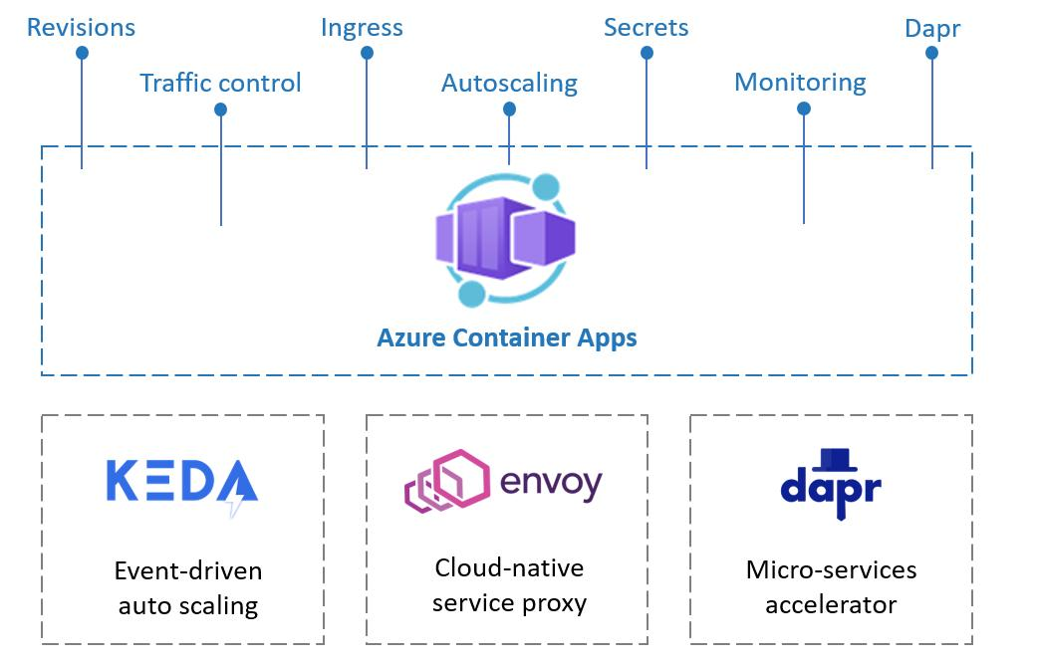
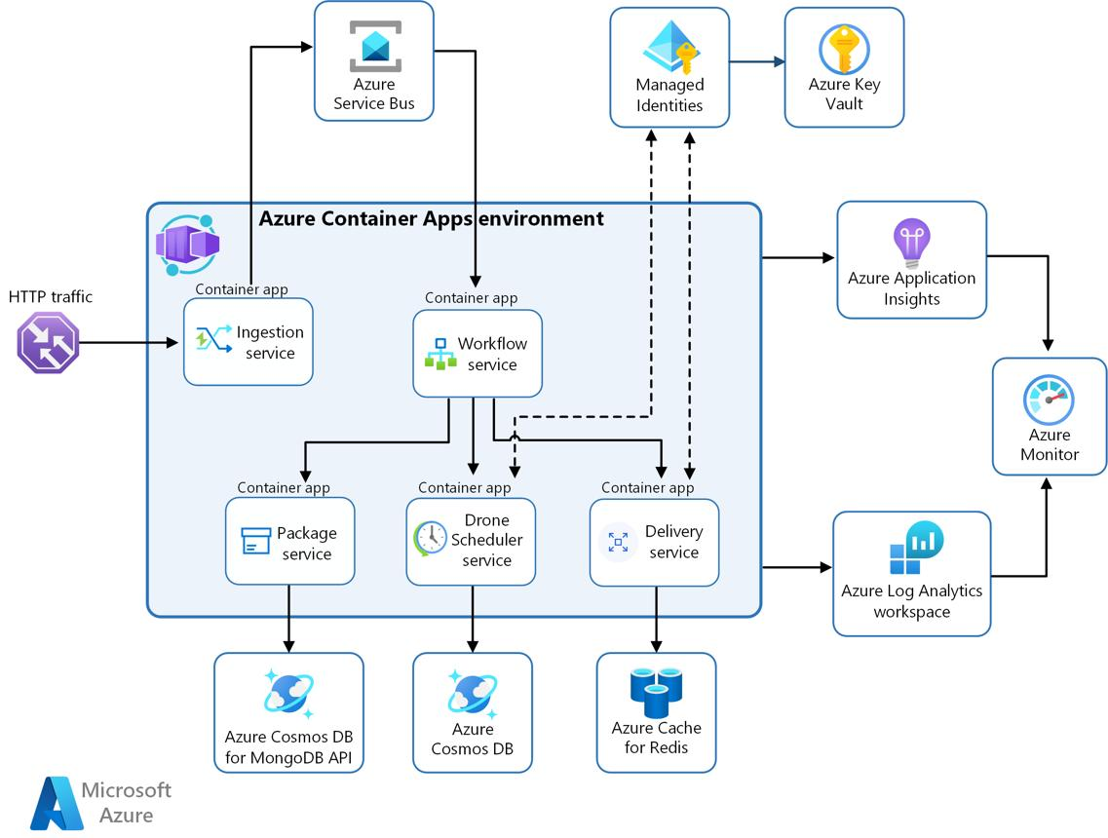
5
Your setup:
- Container App:
stg-krisplus-chatgpt-app
- Running:
  - Node.js / API backend
- Scaling:
MIN=1
MAX=3

What happens:
- App Gateway sends request
- Container App receives
- App:
  - Processes request
  - Calls downstream services

Auto-scaling:
- Based on:
  - CPU
  - Requests
👉 Azure automatically:
- Adds replicas
- Removes replicas

🤖 4. AI + Data Layer
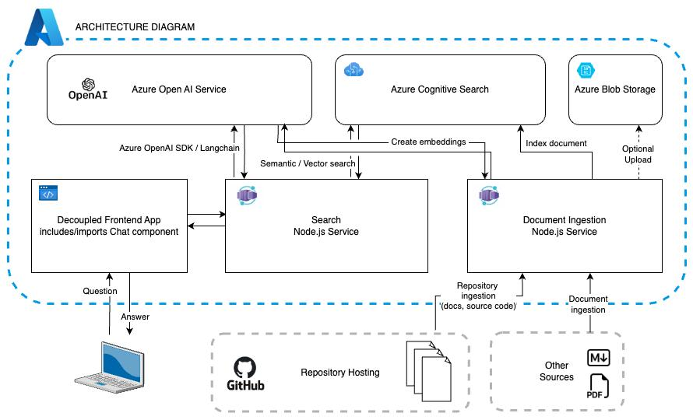
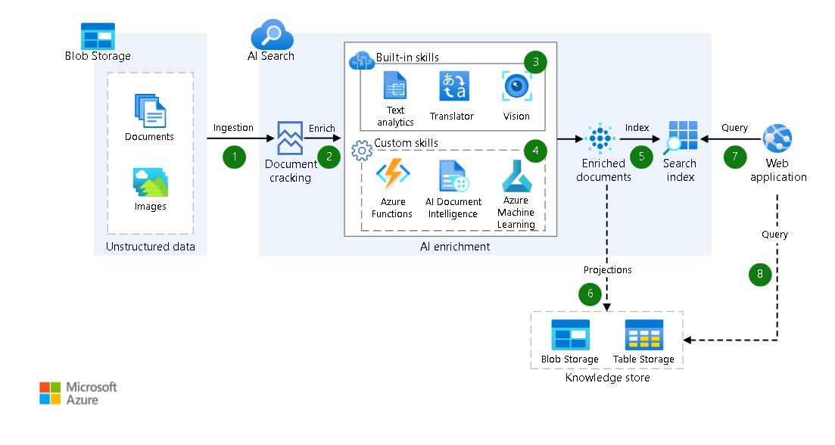
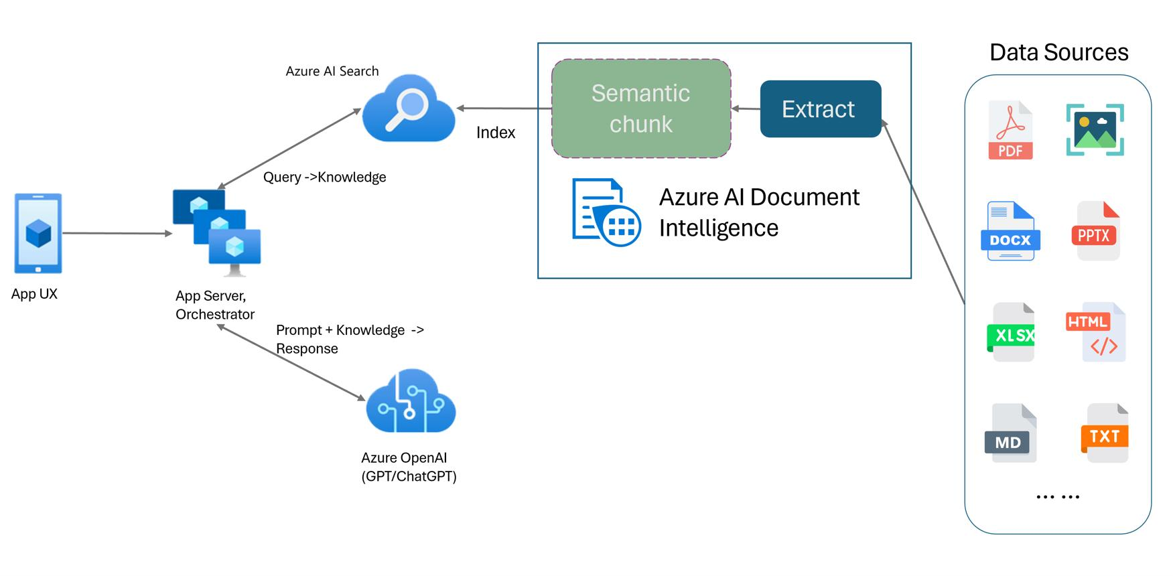
6
Components:
- Azure OpenAI (implied)
- Azure AI Search:
stg-kp-search

Flow inside your app:
- User asks question
- App:
  - Queries Azure Search indexes:
    - deals
    - merchant
    - privilege
- Retrieves relevant data
- Sends to OpenAI (RAG pattern)
- Gets AI response
- Returns to user

🔐 5. Identity & Security
Managed Identity (MSI)
Your config:
APP_GATEWAY_EXISTING_UAMI_NAME="KP_NonProd_AppGw_KV_MI"

Used for:
- App Gateway → Key Vault (SSL cert)
- Container App → ACR (pull image)
- Container App → Azure Search (read access)

Why important:
👉 No passwords stored
👉 Fully RBAC-based auth

📦 6. Container Registry (ACR)
- Shared:
krisplusregistry.azurecr.io
Flow:
- CI/CD builds image
- Push → ACR
- Container App pulls via MSI

📊 7. Monitoring
- Log Analytics
- Application Insights
👉 Tracks:
- Requests
- Failures
- Performance

🔁 End-to-End Request Flow (Real)
Let’s trace a request:

Step 1: User
https://stg-chatgpt.nonprod-krispay.com

Step 2: App Gateway
- SSL termination
- Rule → backend pool

Step 3: DNS Resolution
- Private DNS resolves Container App FQDN

Step 4: Container App
- Receives request
- Processes API

Step 5: Data Fetch
- Calls Azure Search

Step 6: AI Processing
- Sends to OpenAI

Step 7: Response
- Back → App Gateway → User

⚠️ Key Risks in Your Architecture
🔴 1. Shared App Gateway
- Misconfig → impacts DEV/UAT

🔴 2. Subnet sizing (/27)
- Too small → scaling issues later

🔴 3. Private DNS dependency
- If broken → App Gateway cannot resolve backend

🔴 4. RBAC
- MSI missing role → runtime failures

🧠 Why This Architecture is Used
✔ Secure (no public backend)
✔ Scalable (Container Apps)
✔ Cost-efficient (serverless scaling)
✔ Enterprise-ready (App Gateway + RBAC)

🧾 Final Answ

